

**JavaTech Group**



**Payroll management system for information technology company**

**Use-Case Specification: View user**

Version 1.0

**Table of Contents**

1. Ordering Book 3

1.1 Brief Description 3

1.2 Actor 3

2. Flow of Events 3

2.1 Basic Flow 3

3. Special Requirements 4

4. Preconditions 4

5. Postconditions 4

6. Extension Points 4

**Use-Case Specification: View user**

# Ordering Computer

## Brief Description

This use case defines the step of View user. Admin can easily view an employee information from the system by clicking the view user button.

## Actor

Admin.

# Flow of Events

## Basic Flow

From the manage employee view, the admin search for the employee id. The admin then click to view user and the system show up the information of selected employee.

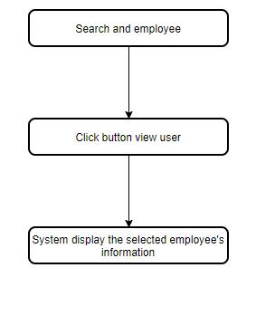

***Basic flow of view employee***

# Special Requirements

No special requirements.

# Preconditions

There are users in the system’s database.

# Postconditions

The admin close information window after view.

# Extension Points

No Extension point.